Stop Monkeying Around

While we are loathe to make fun of people, we at Blog Wyrm believe that ideas are fair game for ridicule and derision. Afterall, a person is precious and has feelings and is worthy of respect. An idea is simply that – an idea. It doesn’t feel, think, or emote. It is either good or bad. Good ideas deserve respect and bad ideas deserve refutation.

Now usually refutation can be done rationally and civilly but when an idea is particularly preposterous it deserve special treatment. The idea of [non-fungible tokens or NFTs](https://en.wikipedia.org/wiki/Non-fungible_token) is one such idea. For those who don’t know what an NFT is (sadly we were once innocent of such knowledge), an NFT is (quoting the Wikipedia article) “a [financial security](https://en.wikipedia.org/wiki/Security_(finance)) consisting of digital data stored in …a [distributed ledger](https://en.wikipedia.org/wiki/Distributed_ledger).” It seems that blockchain is the most popular distributed ledger of record but any one should serve. The value of the NFT comes strictly from the knowledge that the owner uniquely owns the rights to say they uniquely own the NFT. If that reasoning seems circular then yes you’re right it is. The owner neither owns a tangible exclusive good (e.g. a car) nor an intangible non-exclusive good (e.g. the knowledge that the Earth is round). Rather the owner owns the right to brag that they own the only pointer to thing in question. As near as we can figure, its like the owner can claim to ownership of the invention of an idea without having to bother with all the hard work associated with actually doing so.

As a canonical example, consider the [Bored Ape Yacht Club](https://en.wikipedia.org/wiki/Bored_Ape), a series of images similar to the modifed version below.

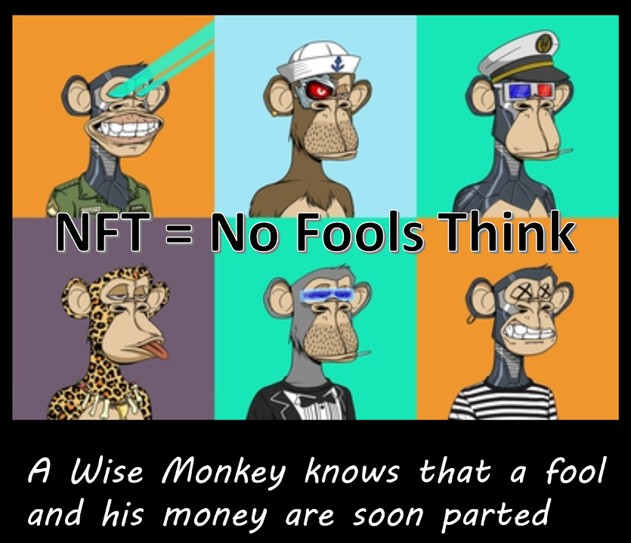

Anyone can enjoy the image but only one person can lay claim to owning the unique pointer to the image. According to Wikipedia, the sales of these tokens have totaled over 1 billion dollars, bought by ‘celebrities’ who obviously have too much money, too little imagination, and an unfulfilled need to be ‘special’. Our only response to these buffoons is to stop monkeying around (doubtful that they have the wit to get that awful pun) and to put their money into something far more useful, like starting a business in underserved neighborhoods or simply a large donation to charity. Sigh…

Now onto the columns.

This month’s [Aristotle2Digital](http://aristotle2digital.blogwyrm.com/?p=1467) begins a deep dive on the Metropolis-Hastings (MH) algorithm. The MH algorithm is an incredibly useful way of solving certain classes of Markov Chain Monte Carlo problems enabling us to solve a rich variety of mathematical and physical problems. This ‘idea’ is one of the most significant numerical methods of the 20th century and no needs an NFT to use or understand it.

It’s hard to believe, but the United States is suffering through a shortage of baby food formula. CommonCents examines some of the reasons why a country that could once feed itself and much of the rest of the world now can’t properly care for some of the most vulnerable within its own borders. Perhaps if some of the economic might that went into buying NFTs were invested in increasing diversity and competition in this important sector things would be looking a lot better for families with small children.

[UndertheHood](http://underthehood.blogwyrm.com/?p=1744) continues to examine entropy that coolest of concepts from classical thermodynamics. In this installment, a concrete problem of supercooled water is examined because it illustrates the both the second law and the use of state variables in a non-trivial physical situation. Maybe this makes entropy the supercoolest of the concepts from classical thermodynamics – certainly cooler than buying an NFT.